GBHC mid season adults survey 2018
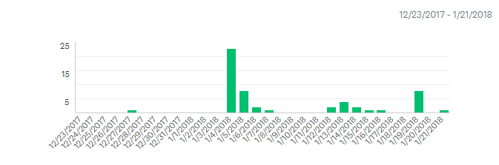

Question 1

Would you consider yourself and active hockey player this season?
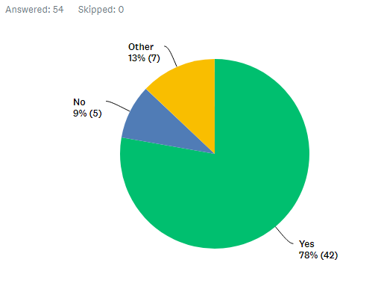

Question 2
What do you enjoy about hockey?
Social/friendship | Exercise | Fun | Competition | Development | The Game
36 | 15 | 8 | 4 | 4 | 14

Question 3
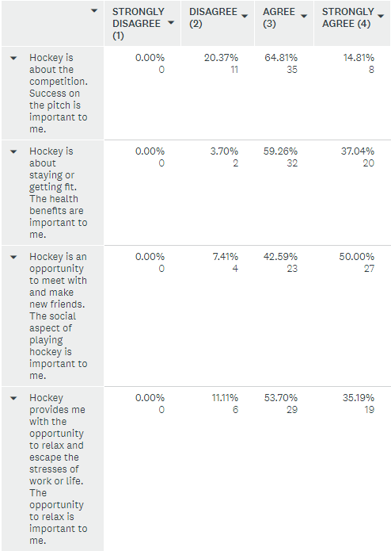
How do you feel about the following statements?

Question 4
Have you attended training this season?
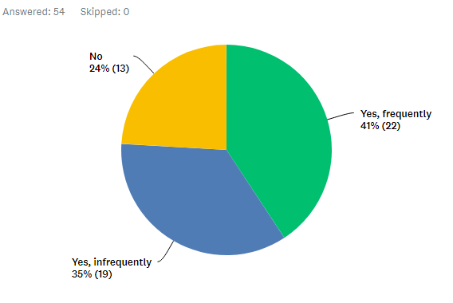

Question 5
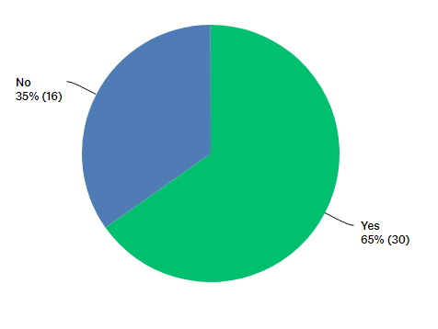
Overall are you satisfied with the current adult training arrangements on Tuesday and Thursday?

work | Enjoyment | Repetition | No development | travel | Child care | Selection process | Start time | Mixed training | Busy life | Light | Attendance
1 | 4 | 2 | 8 | 1 | 2 | 3 | 1 | 1 | 1 | 1 | 3

Comments provided
I find the Thursday session less fun. But feel it is necessary to attend to improve my game.

Question 6
On the scale below where do you feel you stand? (0=always available at weekends 50=if it suites me) 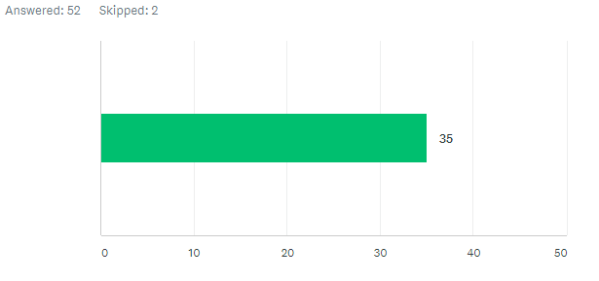

Question 7
What are your thoughts about playing away Fixtures this season?
Family balance | No issue/ love it | Playing out of Hampshire/ cost | Hassle | Better movement between teams | Transport organisation | Work | Team commitment is low
5 | 23 | 13 | 1 | 1 | 6 | 1 | 4

Question 8
What do you think should be the focus of Gosport hockey club for the rest of this season?
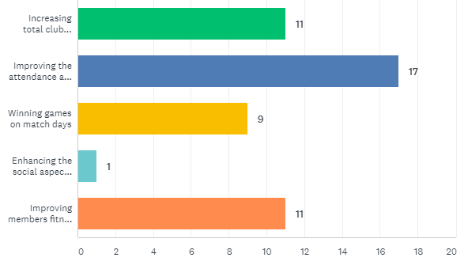
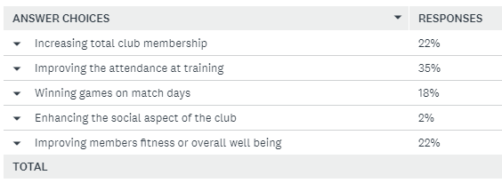

Question 9
What barriers, if any, prevent you from attending training?
Work/ education | Family time/ social events | Enjoyment/attitude of others | Too busy | Injury | Access to site | Quality of training | Travel | Start time | Elitism
19 | 14 | 6 | 2 | 3 | 1 | 1 | 3 | 1 | 1
37% | 27% (13%)* | 11% | 4% | 6% | 2% | 2% | 6% | 2% | 2%
*child care

Question 10
Overall, how do you feel about the club's future?
0=negative 100=positive
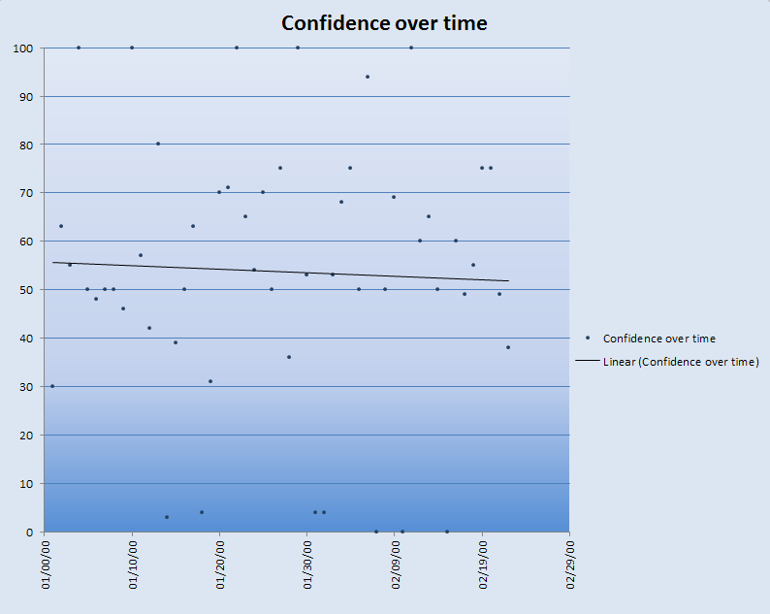
Date format is American, month day year. Year formal is incorrect but all dates are 2018.

